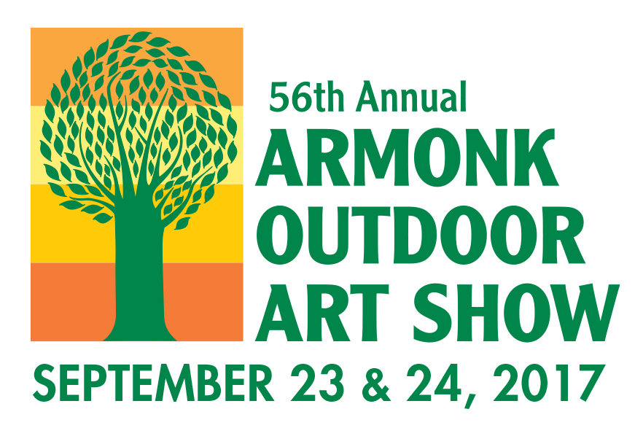

PRESS RELEASE
General Contact: info@armonkoutdoorartshow.org
Media Contact: Anne Curran (914) 629-7529 | acurran@armonkoutdoorartshow.org

56th Annual Armonk Outdoor Art Show
Saturday & Sunday, September 23 & September 24
10:00 am – 5:00 pm, Rain or Shine.
205 Business Park Drive, Armonk, NY 10504

Ranked one of “The Top 50” Fine Art and Fine Craft Fairs in the US by Art Fair SourceBook and among the top “Fine Art and Design Shows” in the New York Metro Area by Sunshine Artist Magazine, the 56th annual Armonk Outdoor Art Show will continue its long tradition of showcasing fresh and diverse art. Over 185 juried artists from 29 states, Israel and Canada, will be featured, with 35 new artists added to the show this year. A broad spectrum of art in every medium and price point will be on display, including painting, mixed mediums, printmaking/drawing/ pastels, sculpture, photography/digital art, wearable art, and fine crafts. Free personal consultants, trained in fine art and home design, are available to assist visitors in selecting art that best fits their taste and decor.

New This Year: More Activities, Food and Drink - All as Fresh as the Art!

Family Activities Tent – All new, fun-filled, free activities under a Big-Top Tent!
Presented by:
First Five – Hands on projects, appropriate for children ages 1-5 with adult participation.
The Harvey School - Interactive programs, appropriate for children ages 5-12.
The Neuberger Museum of Art – A creative exploration and experimentation inspired by the works in the Neuberger Museum’s permanent collection. Fun for children of
all ages.

Food, Craft Beer and Wine – Diverse vendors with new additions!
Including: Luke’s Lobster, Captain Lawrence Brewing and Market North.

Gold Sponsors: Equinox, Houlihan Lawrence, Northern Westchester Hospital, Rosen & Company, Inc.,
White Plains Hospital Medical & Wellness and Westchester Medical Center will entertain and inform.

The Art Show is sponsored by Friends of the North Castle Public Library, Inc., and net proceeds benefit the Town’s libraries in Armonk and North White Plains.
Admission price: $12.00, $10.00 for seniors or with coupon, children under 18 free.
There is ample free parking on site. Sorry, no dogs allowed.
For further information, and discount coupons, visit: www.armonkoutdoorartshow.org

Facebook /armonkoutdoorartshow | Instagram @armonkoutdoorartshow

